**UI Research**

**Oaxaca Characteristics**

* Unique **Mexican Street food**
  + Oaxaca is a city in Mexico
* Great **table service**
  + Friendly, family business vibe

**UI Needs:**

* **Fast, intuitive UI** that **doesn’t need** **training** 
  + UI should be self-explanatory
* Accurate and complete **data** about parts of the **restaurant** 
  + Waiters should be able to search price and contents of each menu item
* Secure **authentication** system
  + Staff must login to access system

**Real Life Examples:**

[**Barrio Bar**](https://barriobars.com/) **-** Unique Mexican bar/restaurant.

Website Colour Theme – Matches papel picados (street banners)

|  |  |  |  |  |
| --- | --- | --- | --- | --- |
|  |  |  |  |  |

Banner shows example of food and vibe of restaurant along with a snappy slogan.

A dropdown menu holds grouped information (e.g. the drinks menu) to remove unnecessary information from bombarding the user. A user may also scroll down to find this information.

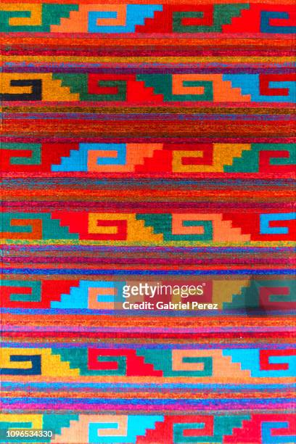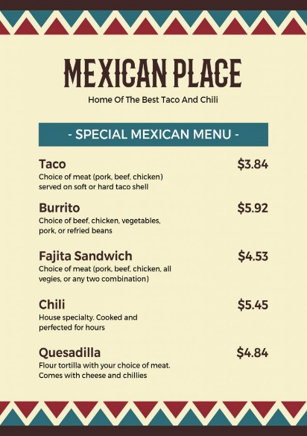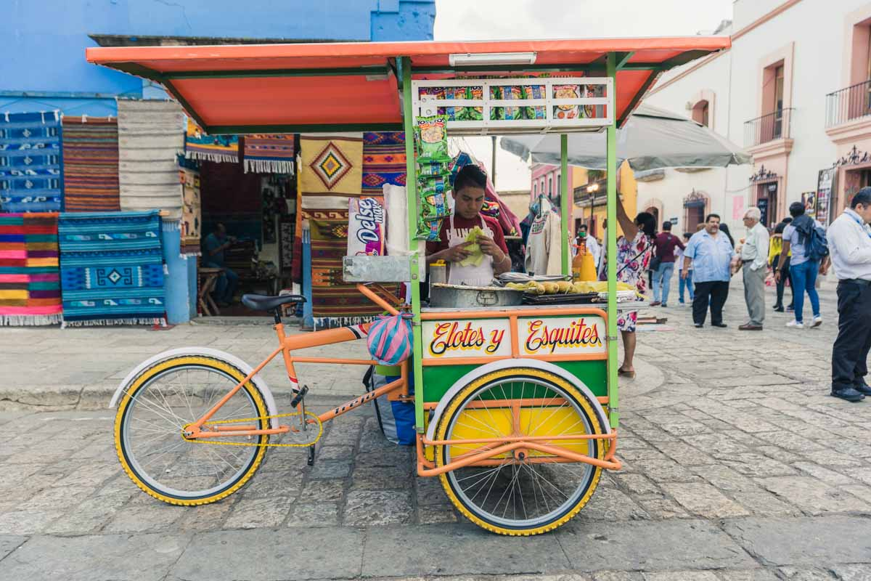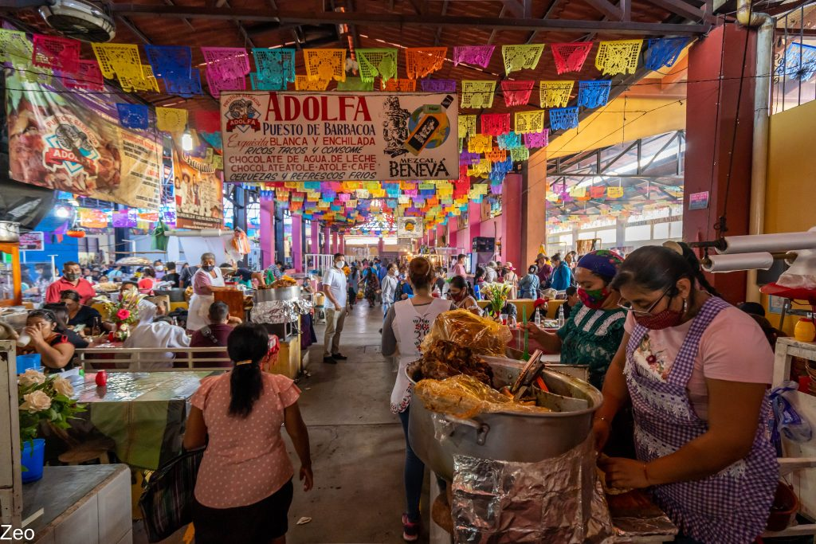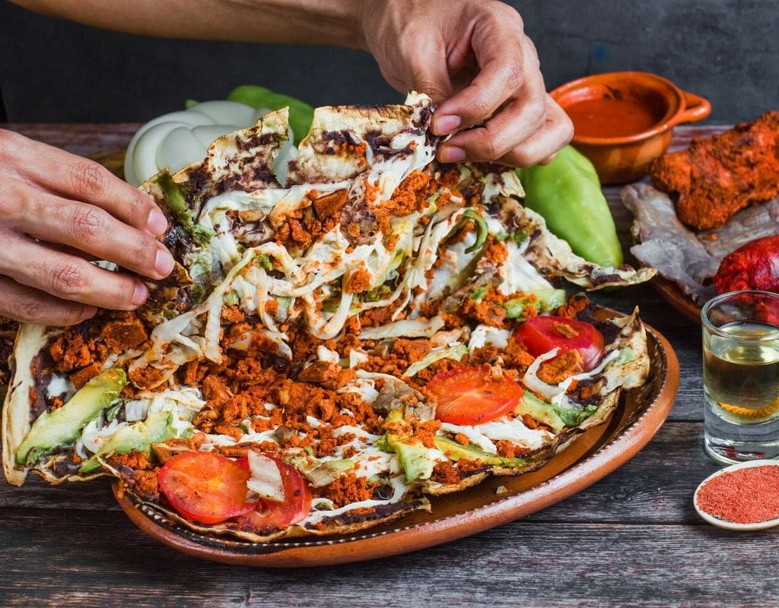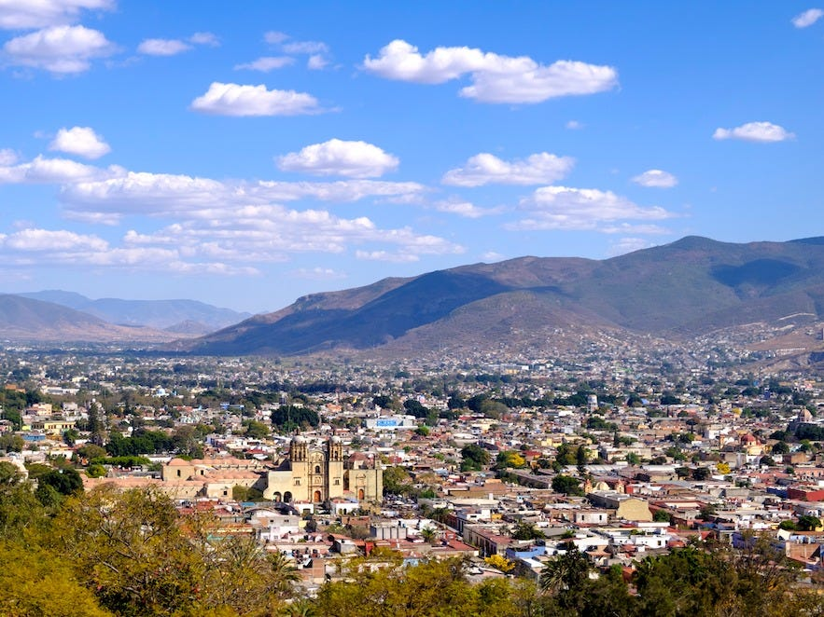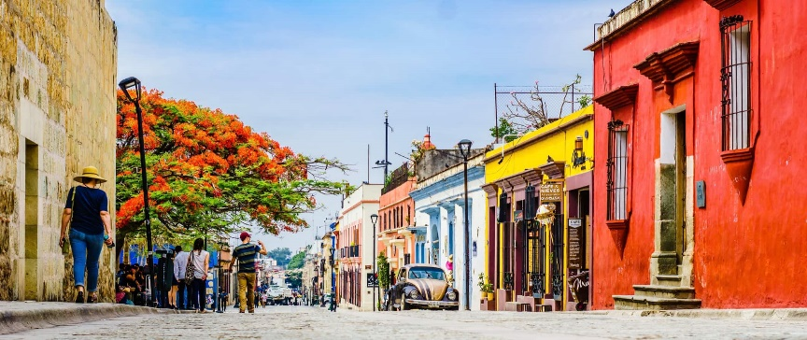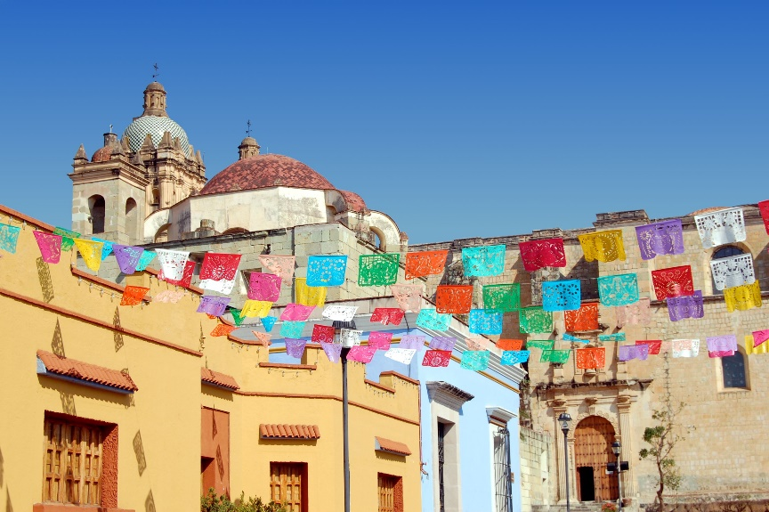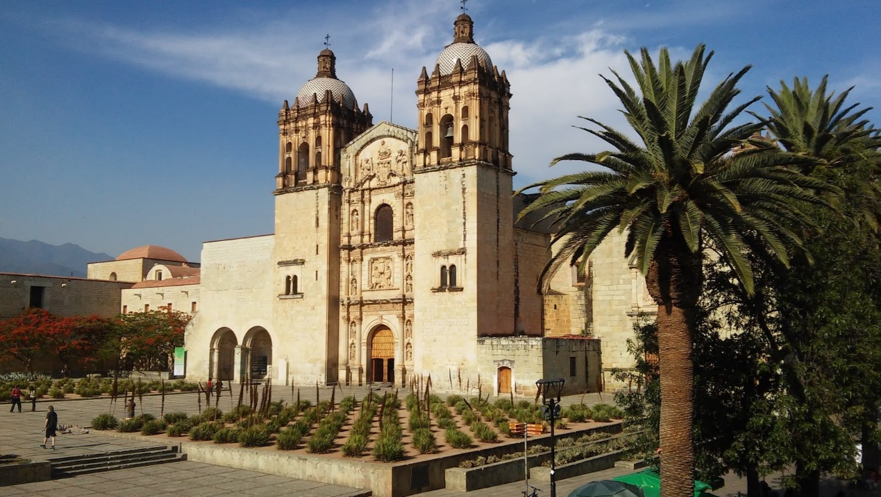**Oaxaca City:**

**Logo**

